

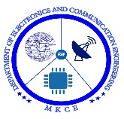

**BLOCKCHAIN IN E-WALLET SYSTEM**

##### A MINOR PROJECT - III REPORT

###### ***Submitted by***

|  |  |
| --- | --- |
| **ASMATH Z** | **927621BEC015** |
| **DHANUSHA R** | **927621BEC034** |
| **DHARSHINI N** | **927621BEC042** |
|  |  |

###### 

##### 

**BACHELOR OF ENGINEERING**

in

**DEPARTMENT OF ELECTRONICS AND COMMUNICATION ENGINEERING**

**M.KUMARASAMY COLLEGE OF ENGINEERING**

(Autonomous)

**KARUR – 639 113**

**OCTOBER 2023**

**M.KUMARASAMY COLLEGE OF ENGINEERING, KARUR**

**BONAFIDE CERTIFICATE**

Certifiedthatthis **18ECP105L - Minor Project - III** report “**BLOCKCHAIN IN E-WALLET SYSTEM** **”**is the bonafide workof “**ASMATH Z(927621BEC015), DHANUSHA R(927621BEC027), DHARSHINI N(927621BEC042)”** who carried out the project work under my supervision in the academic year **2023 -2024 - ODD SEMESTER**.

**SIGNATURE SIGNATURE**

**Dr.A.KAVITHA B.E., M.E., Ph.D.,** **Dr.A.KAVITHA B.E.,M.E.,Ph.D.,**

**HEAD OF THE DEPARTMENT, SUPERVISOR,**

Professor, Professor,

Department of Electronics and Department of Electronics and

Communication Engineering, Communication Engineering,

M.Kumarasamy College of Engineering, M.Kumarasamy College of Engineering, Thalavapalayam, Thalavapalayam,

Karur-639113. Karur-639113.

This report has been submitted for the **18ECP105L – Minor Project - III** final review held at M. Kumarasamy College of Engineering, Karur on ____________________

**PROJECT COORDINATOR**

**INSTITUTION VISION AND MISSION**

**Vision**

To emerge as a leader among the top institutions in the field of technical education.

**Mission**

**M1:** Produce smart technocrats with empirical knowledge who can surmount the global challenges.

**M2:** Create a diverse, fully -engaged, learner -centric campus environment to provide quality education to the students.

**M3:** Maintain mutually beneficial partnerships with our alumni, industry and professional associations

**DEPARTMENT VISION, MISSION, PEO, PO AND PSO**

**Vision**

To empower the Electronics and Communication Engineering students with emerging technologies, professionalism, innovative research and social responsibility.

**Mission**

**M1:** Attain the academic excellence through innovative teaching learning process, research areas & laboratories and Consultancy projects.

**M2:** Inculcate the students in problem solving and lifelong learning ability.

**M3:** Provide entrepreneurial skills and leadership qualities.

**M4:** Render the technical knowledge and skills of faculty members.

**Program Educational Objectives**

**PEO1:** **Core Competence:** Graduates will have a successful career in academia or industry associated with Electronics and Communication Engineering

**PEO2:** **Professionalism:** Graduates will provide feasible solutions for the challenging problems through comprehensive research and innovation in the allied areas of Electronics and Communication Engineering.

**PEO3:** **Lifelong Learning:** Graduates will contribute to the social needs through lifelong learning, practicing professional ethics and leadership quality

**Program Outcomes**

**PO 1: Engineering knowledge:** Apply the knowledge of mathematics, science, engineering fundamentals, and an engineering specialization to the solution of complex engineering problems.

**PO 2: Problem analysis:** Identify, formulate, review research literature, and analyze complex engineering problems reaching substantiated conclusions using first principles of mathematics, natural sciences, and engineering sciences.

**PO 3: Design/development of solutions:** Design solutions for complex engineering problems and design system components or processes that meet the specified needs with appropriate consideration for the public health and safety, and the cultural, societal, and environmental considerations.

**PO 4: Conduct investigations of complex problems:** Use research-based knowledge and research methods including design of experiments, analysis and interpretation of data, and synthesis of the information to provide valid conclusions.

**PO 5: Modern tool usage:** Create, select, and apply appropriate techniques, resources, and modern engineering and IT tools including prediction and modeling to complex engineering activities with an understanding of the limitations.

**PO 6: The engineer and society:** Apply reasoning informed by the contextual knowledge to assess societal, health, safety, legal and cultural issues and the consequent responsibilities relevant to the professional engineering practice.

**PO 7: Environment and sustainability:** Understand the impact of the professional engineering solutions in societal and environmental contexts, and demonstrate the knowledge of, and need for sustainable development.

**PO 8: Ethics:** Apply ethical principles and commit to professional ethics and responsibilities and norms of the engineering practice.

**PO 9: Individual and team work:** Function effectively as an individual, and as a member or leader in diverse teams, and in multidisciplinary settings.

**PO 10: Communication:** Communicate effectively on complex engineering activities with the engineering community and with society at large, such as, being able to comprehend and write effective reports and design documentation, make effective presentations, and give and receive clear instructions.

**PO 11: Project management and finance:** Demonstrate knowledge and understanding of the engineering and management principles and apply these to one’s own work, as a member and leader in a team, to manage projects and in multidisciplinary environments.

**PO 12: Life-long learning:** Recognize the need for, and have the preparation and ability to engage in independent and life-long learning in the broadest context of technological change.

**Program Specific Outcomes**

**PSO1:** Applying knowledge in various areas, like Electronics, Communications, Signal processing, VLSI, Embedded systems etc., in the design and implementation of Engineering application.

**PSO2:** Able to solve complex problems in Electronics and Communication Engineering with analytical and managerial skills either independently or in team using latest hardware and software tools to fulfil the industrial expectations.

|  |  |
| --- | --- |
| **Abstract** | **Matching with POs, PSOs** |
| **<<Abstract keywords>>** | **<<PO1, PO2, PO3, PO4, PO5, PO6, PO7, PO8, PO9, PO10, PO11, PO12, PSO1, PSO2>>** |

**ACKNOWLEDGEMENT**

Our sincere thanks to Thiru.M.Kumarasamy, Chairman and Dr.K.Ramakrishnan, Secretary of M.Kumarasamy College of Engineering for providing extraordinary infrastructure, which helped us to complete this project in time.

It is a great privilege for us to express our gratitude to Dr.B.S.Murugan., B.Tech., M.Tech., Ph.D., Principal for providing us right ambiance to carry out this project work.

We would like to thank Dr.A.Kavitha, B.E., M.E., Ph.D., Professor and Head, Department of Electronics and Communication Engineering for his unwavering moral support and constant encouragement towards the completion of this project work.

We offer our wholehearted thanks to our Project Supervisor, Dr.A.KAVITHA B.E.,M.E.,Ph.D Professor,.,, Department of Electronics and Communication Engineering for his precious guidance, tremendous supervision, kind cooperation, valuable suggestions, and support rendered in making our project successful.

We would like to thank our Minor Project Co-ordinator, Dr.K.Karthikeyan, B.E., M.Tech., Ph.D., Associate Professor, Department of Electronics and Communication Engineering for his kind cooperation and culminating in the successful completion of this project work. We are glad to thank all the Faculty Members of the Department of Electronics and Communication Engineering for extending a warm helping hand and valuable suggestions throughout the project. Words are boundless to thank our Parents and Friends for their motivation to complete this project successfully.

**ABSTRACT**

The integration of blockchain technology into E-Wallet systems has brought about a significant transformation in the landscape of digital finance. This paper explores the various ways in which blockchain enhances security, transparency, and efficiency in E-Wallet transactions. It delves into the decentralized nature of blockchain, which eliminates the need for intermediaries, reducing transaction costs and minimizing the risk of fraud. Additionally, the immutability of blockchain records ensures the integrity of transaction history, fostering trust among users. The use of smart contracts further automates and streamlines financial processes, offering unprecedented convenience. The adoption of blockchain technology within E-Wallet systems has ushered in a new era of digital finance, characterized by enhanced security, transparency, and accessibility. This paper examines the profound impact of blockchain on E-Wallet ecosystems, emphasizing its role in safeguarding sensitive financial data through cryptographic principles. By decentralizing transaction verification and record-keeping, blockchain reduces reliance on traditional financial intermediaries, lowering costs and expediting transactions. Smart contracts, embedded within blockchain networks, automate and enforce agreements, offering unprecedented efficiency and convenience. This paper provides a comprehensive overview of blockchain's real-world applications in E-Wallet systems and underscores its potential to reshape the future of digital finance, making it more secure, efficient, and inclusive.

**TABLE OF CONTENTS**

|  |  |  |  |
| --- | --- | --- | --- |
| **CHAPTER No.** | **CONTENTS** | | **PAGE No.** |
|  | **Institution Vision and Mission** | | iii |
|  | **Department Vision and Mission** | | iii |
|  | **Department PEOs, POs and PSOs** | | iv |
|  | **Abstract** | | viii |
|  | **List of Figures** | | x |
|  | **List of Abbreviations** | | xi |
| **1** | **INTRODUCTION** | | 1 |
|  | 1.1 | Objective | 2 |
|  | 1.2 | Problem Statement | 3 |
| **2** | **LITERATURE SURVEY** | | 4 |
| **3** | **EXISTING SYSTEM`** | | 6 |
| **4** | **PROPOSED SYSTEM** | | 8 |
| **5** | **Project Methodology** | | 9 |
|  | 5.1 | Blockchain Platform | 9 |
|  | 5.2 | CRYPTO WALLETS IN BLOCKCHAIN | 9 |
|  | 5.3 | Bitcoin Transfer | 11 |
| **7** | **RESULT AND DISCUSSION** | | 14 |
| **8** | **CONCLUSION AND FUTURE SCOPE** | | 16 |
|  | **APPENDICES** | |  |
|  | **REFERENCES** | | 18 |

**LIST OF FIGURES**

|  |  |  |
| --- | --- | --- |
| **FIGURE No.** | **TITLE** | **PAGE No.** |
|  | Common Language Runtime | 10 |
|  |  |  |
|  |  |  |

**LIST OF ABBREVIATIONS**

|  |  |  |
| --- | --- | --- |
| **ACRONYM** |  | **ABBREVIATION** |
| CLS | - | Common Language Specification |
| CPU | - | Central Processing Unit |

CHAPTER 1  
INTRODUCTION

A key goal of the Semantic Web concept used in this project is to shift social interaction patterns from a producer-centric paradigm to a consumer-centric one. Treating customers as the most valuable assets and making the business models work better for them are at the core of building successful consumer-centric business models. It follows that customizing business processes constitutes a major concern in the realm of a knowledge-pull-based human semantic Web. Ontologies are used in an increasing range of applications, notably the Semantic web, and essentially have become the preferred modeling tool.

The main aim of this project is to customize the web services with the help of user profiles consisting of personal information thereby making the web interactive. In real world, it tends to associate with automated systems as they provide many benefits than doing the same thing manually. The system that I have designed, will automate the searching results of users to create an accurate match with the personal information such as age, gender, income etc. This match will predict the user intention of searching several web services. The web services designed in this project include online shopping of books and electronic gadgets, medical information and Education Counseling services. The database will be updated by the administrator by adding several products needed by the users of this website. When data mining tools are implemented on high performance parallel processing systems, they can analyze massive databases in minutes. Faster processing means that the system can automatically experiment with more models to understand complex data of user. Larger databases, in turn, yield improved predictions. High speed makes it practical for users to access this huge database in reduced time resulting in better search results.

* 1. **OBJECTIVE**

To develop and provide a secure, user-friendly blockchain e-wallet solution that enables individuals and businesses to manage, store, and transact cryptocurrencies and digital assets seamlessly, while fostering financial inclusion and promoting the adoption of blockchain technology. Ensuring the wallet is highly secure to protect users' funds and data from unauthorized access or theft. Creating an intuitive and easy-to-use interface that caters to both experienced cryptocurrency users and newcomers. Ensuring compatibility with a wide range of blockchain networks and digital assets. Seamless Transactions: Enabling quick and reliable transactions within the wallet while keeping fees reasonable.

* 1. PROBLEM STATEMENT

In the rapidly evolving landscape of digital finance, cryptocurrencies and blockchain technology have gained significant prominence. However, several critical challenges persist in the realm of digital wallets, necessitating the development of a state-of-the-art blockchain e-wallet solution. blockchain e-wallet project aims to address these challenges by developing a next-generation e-wallet solution. Implementing cutting-edge security protocols to safeguard user assets and data from cyber threats. Designing a user-friendly interface with educational resources to cater to both beginners and experienced users, promoting ease of use and adoption. Enabling seamless management of digital assets across various blockchain networks within a single wallet, reducing user confusion.

CHAPTER 2

LITERATURE REVIEW

The author discusses how Bitcoin-beyond blockchain work bridges those flaws and some of the unresolved problems. Cryptocurrencies blockchains specifications and guarantees do not fit FinTech 's requirements on security and privacy from transaction throughput to primitives. It analyses the safeguarding process of the distributed database and suggests a solution for the challenges of retaining the information confidentiality in them without token based on Blockchain. The authors say that without using mining and tokens, blockchain would significantly unravel procedure to maintain the confidentiality and validity of knowledge regarding bank transactions. In this work Blockchain technology addresses the problem of cryptography consensus. And if there is a method to assure financial activity and transaction actions are stored in a particular database without the central authority's intervention. It analyses the main design and technological features showcased by blockchain, and presents scenarios into which blockchain applications can be applied. The research paper focuses on the use of blockchain as the Central Bank Digital Currency (shortly known as CBDC) basic prototype technology. The Central Bank Digital Currency prototype will benefit from the supervision, payment and use of the Blockchain technology. Problems such as safeguarding the confidentiality, transparency and speed of user transactions should be resolved to use the blockchain as CBDC 's fundamental technology. This paper explores the challenges and opportunities posed by banking through the introduction of blockchain technology. The blockchain technology will turn the global financial system to achieve sustainable development, using systems that are more effective than they are at the moment. Starting a prototype of E2E (end-to-end) interbank Payment Systems (IBPS) based on Hyperledger Fabric company's blockchain network. The model shows the business blockchain manifesto, which are defined by Hyperledger Fabric, capable to ease more productive and stable payment solutions. The research proposes a model of systemic innovation to explore and track pathways to innovation. In order to Understand the growth cycle of innovation and the approach for winning market share of the banking sector, this model may be applied to any industry. The empirical results indicate the situation in which lots of banks are yet to develop or migrate their tradition banking system to Blockchain technology. The study, which is established on the structural innovative prototype, showcases the currently low structural characteristic of Blockchain banking.

**CHAPTER 3**

**EXISTING SYSTEM**

Existing blockchain e-wallet systems encompass a range of digital wallet solutions that have been developed and are currently available to users and businesses in the cryptocurrency and blockchain ecosystem. These systems serve as the foundation for digital asset management, storage, and transactions, catering to the needs of a diverse user base. Existing blockchain e-wallets are characterized by their robust security measures, including password protection, PINs, biometric authentication, and encryption of private keys. They provide support for various cryptocurrencies, often extending to different blockchain networks and custom tokens. User-friendly interfaces offer easy navigation, transaction history tracking, and balance management. Additionally, backup and recovery mechanisms, such as mnemonic phrases, are integrated into these wallets to ensure the safety of digital assets. A key feature of many existing e-wallets is their cross-platform accessibility, enabling users to access their wallets on mobile devices, desktop applications, and through web-based interfaces. The ability to synchronize wallet data across multiple devices further enhances the user experience. Regulatory compliance, customer support, third-party integrations, and security best practices are also factors considered in the design of these e-wallet systems. Open-source and closed-source wallets are available, catering to the preferences and needs of different user groups. Evaluation of these existing systems is crucial for understanding the strengths and weaknesses of current offerings, which can inform the development of future blockchain e-wallet projects.

**CHAPTER 4**

**PROPOSED SYSTEM**

The proposed blockchain e-wallet system represents a forward-looking solution that aims to address the challenges and limitations of existing e-wallets, facilitating a secure, user-friendly, and inclusive digital asset management experience. This next-generation system will prioritize security with cutting-edge measures such as biometric authentication, multi-signature support, and advanced encryption, ensuring the protection of users' assets and data. It will feature a user-friendly interface that caters to both seasoned cryptocurrency enthusiasts and newcomers, offering educational resources and intuitive design to enhance usability. One of the standout features will be its seamless multi-blockchain support, allowing users to manage a diverse range of digital assets across different blockchain networks, reducing complexity and promoting interoperability. In line with the goal of financial inclusion, the wallet will be designed to serve unbanked and underbanked populations, offering them access to the global financial system. Regulatory compliance will be central to the system's framework, helping users navigate the evolving legal landscape while staying compliant. Cost-effective transactions will be a key focus, reducing fees and making cryptocurrency use more affordable for everyday transactions. The proposed blockchain e-wallet system is poised to not only tackle the existing challenges but also propel the adoption of blockchain technology while delivering a secure, accessible, and user-centric experience to a broad user base. Instead of creating wallets with a password, mobile number or email address, the wallet should be created using a Phrase. This Phrase is provided to the specific user at the time of wallet creation.

**CHAPTER 5**

**PROJECT METHODOLOGY**

**5.1 BLOCKCHAIN PLATFORM**

Ethereum is known for its robust smart contract capabilities, making it suitable for a wide range of decentralized applications (DApps) and blockchain wallets. Ethereum has a vast and active developer community, which means you can find resources and support readily available. If your wallet project involves integration with decentralized finance (DeFi) applications or tokens, Ethereum is a natural choice due to its prominence in the DeFi space. Token Standards: Ethereum supports popular token standards like ERC-20 and ERC-721, which may be important if your wallet needs to handle a variety of tokens. Hyperledger (e.g., Hyperledger Fabric) Enterprise Focus: Hyperledger is often preferred for enterprise-grade blockchain solutions due to its modular architecture and permissioned network options. If your project requires strict control over who can access the blockchain, Hyperledger Fabric offers robust permissioning features. Hyperledger projects are designed with interoperability in mind, making it a good choice if your wallet needs to interact with other enterprise systems. Binance Smart Chain BSC is known for its low transaction fees, which can be advantageous if your wallet's primary user base includes retail users who are sensitive to transaction costs.

**5.2 CRYPTO WALLETS IN BLOCKCHAIN**

This implementation of a mobile-based crypto wallet using blockchain could be seen in the form of a Coinbase wallet, which is a mobile-based crypto wallet. This Crypto wallet is a mobile-based wallet, apart from transaction facilities they do offer multi-layer authentications, such as while accessing Coinbase Account from the browser, they ask for OTP as well as authentication for the device using email facility.

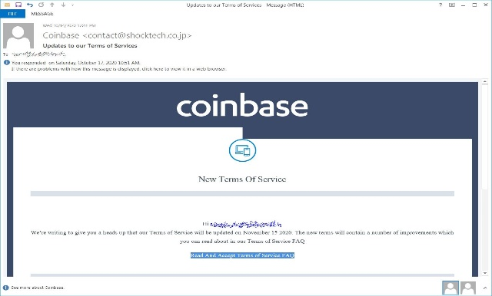

Figure 5.1 – Coinbase E mail Authentication

5.3 BITCOIN TRANSACTION

Below is a transaction snip obtained using real-time bitcoin transfer from Coinbase Portfolio to Coinbase wallet. The transaction is a real-time transaction. A typical Bitcoin transaction Takes around 10 minutes of time, to reach the transaction confirmation stage. Coinbase portfolio is a trading platform of cryptocurrency, which allows a user to trade and transfer crypto in various cryptocurrency as Litecoin, Bitcoin, etc. When a user trades in cryptocurrency and wants to transfer this cryptocurrency to its own or to a different wallet, the portfolio captures the last updated currency (i.e., USD$) value at the time of crypto transfer transaction.

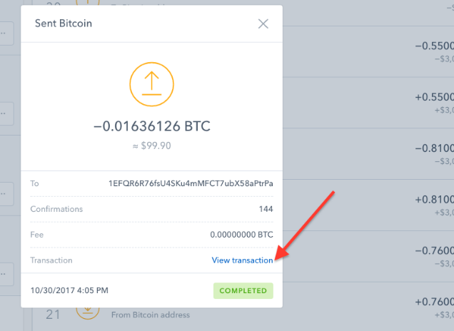

Figure 5.2**–** Real-time Transaction of bitcoin from Coinbase portfolio to Coinbase wallet.

The above figure contains the transaction record of bitcoin which is initiated to Coinbase wallet from Coinbase Portfolio. The time and date stamps are associated with the transaction logs as displayed in above figure. An average user has to wait for 10 minutes for a miner to record a transaction on the blockchain. Below is the snippet which contains Blockchain log for this transaction.



Figure 5.3**–** Blockchain Record of a Bitcoin transfer

The above figure contains the blockchain record on which the transaction records are being maintained to ensure all the transaction are recorded. For each transaction a miner fee is charged depending on the amount of bitcoin transfer equivalent to Santoshi.

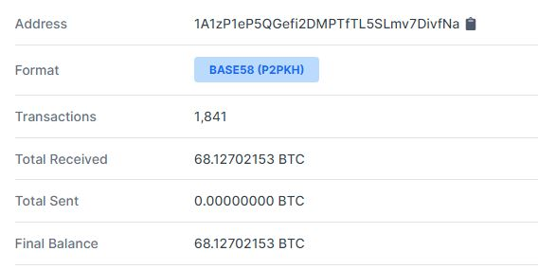

Figure 5.4 **–** Blockchain Record of a Bitcoin transfer

The above figure displays the Hash number or address, status of the transaction, date and time of transaction, the block number on to which transaction was recorded, along with all the bitcoin transfer equivalent to Satoshi. Every Transaction in the blockchain is recorded by miners by charging miner fees in the form of some Satoshi. The Coinbase wallet offers wallet creation, unlike others where they ask for a password. Instead, Coinbase wallet creation only requires a user phrase that has to remember by user and the same can be stored of google drive as a backup code. There is no way to recover the account if the user has lost or forgot the phrase, meaning the user will no longer be able to access any of the wallet cryptocurrencies.

**CHAPTER 6**

**RESULT AND DISCUSSION**

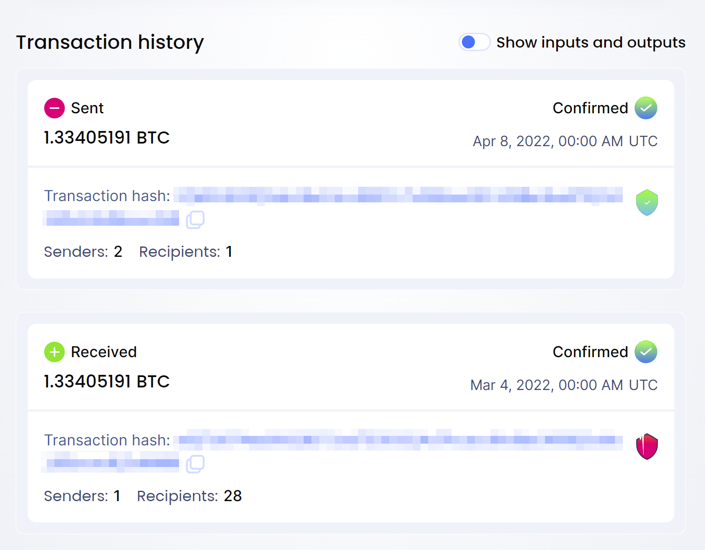

Figure 6.1- The output of transaction

The above figure shows the output of transaction history which is in privacy key. We do require blockchain implementation in the core banking system so that we can ensure that each transaction is authenticated and it is initiated by the user itself. Although the adoption of this technology is very feasible and reduces the security overhead that comes with a traditional banking system such as centralization. Blockchain-based wallet system and banking system dismantles the centralization of data and stores the data at several places since its key to success is the distribution of data across the network at the distributed databases. The data and customers both are very secured in the hands of the blockchain-based technology banking system.

**CHAPTER 7**

**CONCLUSION AND FUTURE SCOPE**

The adoption of technology depends on the requirements of the business here in the case is for the banking system. The no of profits margin derives the adoption of technology. Most of the Banks around the globe have adopted blockchain as they value customer's privacy in the first place. There are always pros and cons related to each technology which goes the same in the case of blockchain too. They only problem with technology is the cost. The cost drives the business day to day operations, so this is where the banks have to think carefully before the adoption of this technology. The blockchain based banking system becomes more temper proof when it is powered by blockchain.

The future scope for blockchain e-wallets is promising and continues to evolve as blockchain technology matures and new use cases emerge. Here are some of the potential future developments and trends in the blockchain e-wallet space

* + Interoperability
  + DeFi Integration
  + Cross-Chain Functionality
  + Enhanced Security
  + Multi-Signature Wallets
  + Decentralized Identity
  + Cross-Border Payment
  + Integration with Central Bank Digital Currencies (CBDC)
  + Mobile and Cross-Platform Wallets

**APPENDICES**

import java.io. IOException;

import java.io.PrintWriter;

import java.sql.Connection;

import java.sql.DriverManager;

import java.sql.ResultSet;

import java.sql.Statement;

import java. util.Random;

import com.google.zxing.BarcodeFormat;

import com.google.zxing.WriterException;

import com.google.zxing.client.j2se.MatrixToImageWriter;

import com.google.zxing.common.BitMatrix;

import com.google.zxing.oned.Code128Writer;

import com.google.zxing.qrcode.QRCodeWriter;

import dataset.AesEncryption;

import java.io.File;

import java.io.FileOutputStream;

import javax.servlet.RequestDispatcher;

import javax.servlet.ServletException;

import javax.servlet.http.HttpServlet;

import javax.servlet.http.HttpServletRequest;

import javax.servlet.http.HttpServletResponse;

import javax.servlet.http.HttpSession;

<%--

Document : index

Created on : Feb 14, 2013, 10:00:00 PM

Author : XXXYYY

--%>

<%@page import="java.sql.ResultSet"%>

<%@page import="java.sql.Statement"%>

<%@page import="java.sql.DriverManager"%>

<%@page import="java.sql.Connection"%>

<%@page import="java.text.SimpleDateFormat"%>

<%@page import="java.text.SimpleDateFormat"%>

<%@page import="java.util.Calendar"%>

<!DOCTYPE html PUBLIC "-//W3C//DTD XHTML 1.0 Strict//EN" "http://www.w3.org/TR/xhtml1/DTD/xhtml1-strict.dtd">

<html xmlns="http://www.w3.org/1999/xhtml" xml:lang="en">

<head>

<title>Marketing Company | Inner</title>

<meta http-equiv="Content-Type" content="text/html; charset=utf-8" />

<link href="script/style.css" rel="stylesheet" type="text/css" />

<!--[if lt IE 7]><link href="script/ie.css" rel="stylesheet" type="text/css" /><![endif]-->

<!--[if IE 7]><link href="script/ie7.css" rel="stylesheet" type="text/css" /><![endif]-->

<style type="text/css">

<!--

.style48 {color: #003399}

-->

</style><link href="screen.css" rel="stylesheet" type="text/css" media="screen" /><script type="text/javascript" src="js/datetimepicker_css.js"></script>

<script type="text/javascript" src="js/general.js"></script><SCRIPT LANGUAGE="JavaScript">

<!-- This script and many more are available free online at -->

<!-- The JavaScript Source!! http://javascript.internet.com -->

<!-- Begin

function checkEmail(myForm) {

if (/^\w+([\.-]?\w+)*@\w+([\.-]?\w+)*(\.\w{2,3})+$/.test(myForm.a11.value)){

return (true)

}

alert("Invalid E-mail Address! Please re-enter.")

return (false)

}

// End -->

</script>

<style type="text/css">

<!--

.style63 {color: #FFFFFF}

.style64 {font-size: 16px}

.style66 {

font-size: 24px;

font-weight: bold;

}

-->

</style>

</head>

<body id="inner">

<div id="wrapper">

<div id="header"> <a href="#" id="logo" class="replace">Best Marketing Company</a>

<div id="navigation" style="width:1100px;">

<ul >

<li><a href="admin.jsp">Home</a></li>

<li><a href="addproduct.jsp">Product</a></li>

<li><a href="customerinform.jsp">Customer</a></li>

<li><a href="transactions">Transaction</a></li>

<li><a href="login.jsp">Logout</a></li>

</ul>

</div>

<!--navigation ends-->

<div id="connect">

<p class="left">connect with us:</p>

<ul class="right">

<li id="twitter"><a href="#" class="replace">Twitter</a></li>

<li id="facebook"><a href="#" class="replace">Facebook</a></li>

<li id="in"><a href="#" class="replace">IN</a></li>

</ul>

</div>

<!--connect ends-->

</div>

<!--header ends-->

<div id="inner_content">

<div id="inner_main_column" style="width:960px;" >

<h1 class="style48">About Best Marketing Company</h1>

<table width="1017" border="0">

<tr>

<td width="1011" height="46" align="center"><span class="style48 style66">TRANSACTION DETAILS</span></td>

</tr>

<tr>

<td height="161"><table border="0" align="center">

<tr>

<td width="976" height="126"><FORM action="" method="post" >

<table border="0" align="center" bgcolor="#FFFFFF">

<tr>

<td width="965"><table width="951" border="0" bgcolor="" align="center">

<tr>

<td width="945"><table width="967" height="39" border="0" bgcolor="#003399">

<tr>

<td width="97" height="33"><div align="center" class="style64 style63 style55"><strong>Product Id </strong></div></td>

<td width="115"><div align="center" class="style64 style63 style55"><strong>P Name </strong></div></td>

<td width="79"><div align="center" class="style64 style63 style55"><strong>Price</strong></div></td>

<td width="129"><div align="center" class="style64 style63 style55"><strong>Discount </strong></div></td>

<td width="98"><div align="center" class="style64 style63 style55"><strong> Amount </strong></div></td>

<td width="121"><div align="center" class="style64 style63 style55"><strong>No of Product</strong></div></td>

<td width="129"><div align="center" class="style64 style63 style55"><strong>Total Amount </strong></div></td>

<td width="151"><div align="center" class="style64 style63 style54 style53"><strong>Paid Date </strong></div></td>

</tr>

</table></td>

</tr>

<tr>

<td><table width="959" height="39" border="0">

<%

try

{

String a11=null;

HttpSession so = request.getSession(true);

System.out.println(a11);

int flag=0;

String url="jdbc:mysql://localhost:3306/purchase";

Class.forName("com.mysql.jdbc.Driver");

Connection con=DriverManager.getConnection(url,"root","root");

Statement st=con.createStatement();

ResultSet rs = st.executeQuery("select * from purchase ");

while(rs.next())

{

%>

<tr>

<td width="94" height="33"><div align="center"><%=rs.getString(1)%></div></td>

<td width="117"><div align="center"><%=rs.getString(4)%></div></td>

<td width="83"><div align="center"><%=rs.getString(5)%></div></td>

<td width="131"><div align="center"><%=rs.getString(6)%></div></td>

<td width="96"><div align="center"><%=rs.getString(7)%></div></td>

<td width="128"><div align="center"><%=rs.getString(8)%></div></td>

<td width="123"><div align="center"><%=rs.getString(8)%></div></td>

<td width="153"><div align="center"><%=rs.getString(9)%></div></td>

</tr><% }

}catch (Exception e) {

out.println(e);

}

%>

</table></td>

</tr>

</table></td>

</tr>

</table>

</FORM></td>

</tr>

</table></td>

</tr>

</table>

<p>&nbsp;</p>

<p>&nbsp;</p>

</div>

<!--main column ends-->

<!--inner right column ends-->

<div class="clear"></div>

</div>

<!--content ends-->

<div class="footerclear"></div>

</div>

<!--wrapper ends-->

<div id="footer_container">

<div id="footer">

<p class="left">Best Marketing Company</p>

<ul >

<li><a href="index.jsp">Home</a></li>

<li><a href="about.jsp">About</a></li>

<li><a href="register.jsp">Create Account</a></li>

<li><a href="login.jsp">Login</a></li>

</ul>

</div>

<!--footer ends-->

</div>

<!--footer ends-->

<div align=center>This template downloaded form <a href='http://all-free-download.com/free-website-templates/'>free website templates</a></div></body>

</html>

**REFERENCES**

1. Eyal, I. (2017). Blockchain Technology: Transforming Libertarian Cryptocurrency Dreams to Finance

and Banking Realities Computer MDPI AG

2. Popova, N.A., Buta ova, N.G. (2019). Research of a possibility of using blockchain technology without

tokens to protect banking transactions Proceedings of the 2019 IEEE Institute of Electrical and Electronics

Engineers Inc.

3. Wu, T., Liang, X. (2017). Exploration and practice of inter-bank application based on

blockchain ICCSE 2017 - 12th International Conference on Computer Science and Education Institute of

Electrical and Electronics Engineers Inc.,

4. Sun, H., Mao, H., Bai, X., (...), Hu, K., Yu, W. (2018). Multi-blockchain model for central bank digital

currency Parallel and Distributed Computing, Applications and Technologies IEEE Computer Society

5. Cocco, L., Pinna, A., Marchesi, M. (2017). Banking on blockchain: Costs savings thanks to the blockchain

technology Future Internet MDPI AG

blockchain Proceedings of 2018 IEEE 3rd Advanced Information Technology Institute of Electrical and

Electronics Engineers Inc.

6. Li, L., Sy, M., McMurray, A. (2018). Blockchain Innovation and Its Impact on Business

OUTCOME